1. Model Architecture:

○ Explain the transformer architecture in detail. How do self-attention mechanisms contribute to its success?
Transformer is completely based on the attention mechanisms, removing the need for recurrence and convolutions. The transformer has an encoder-decoder structure. The encoder helps to create continuous representation of a given input sequence of symbol representation(tokens). The decoder generates an output sequence given the representation from the encoder module as one token at a time as shown in the diagram below.
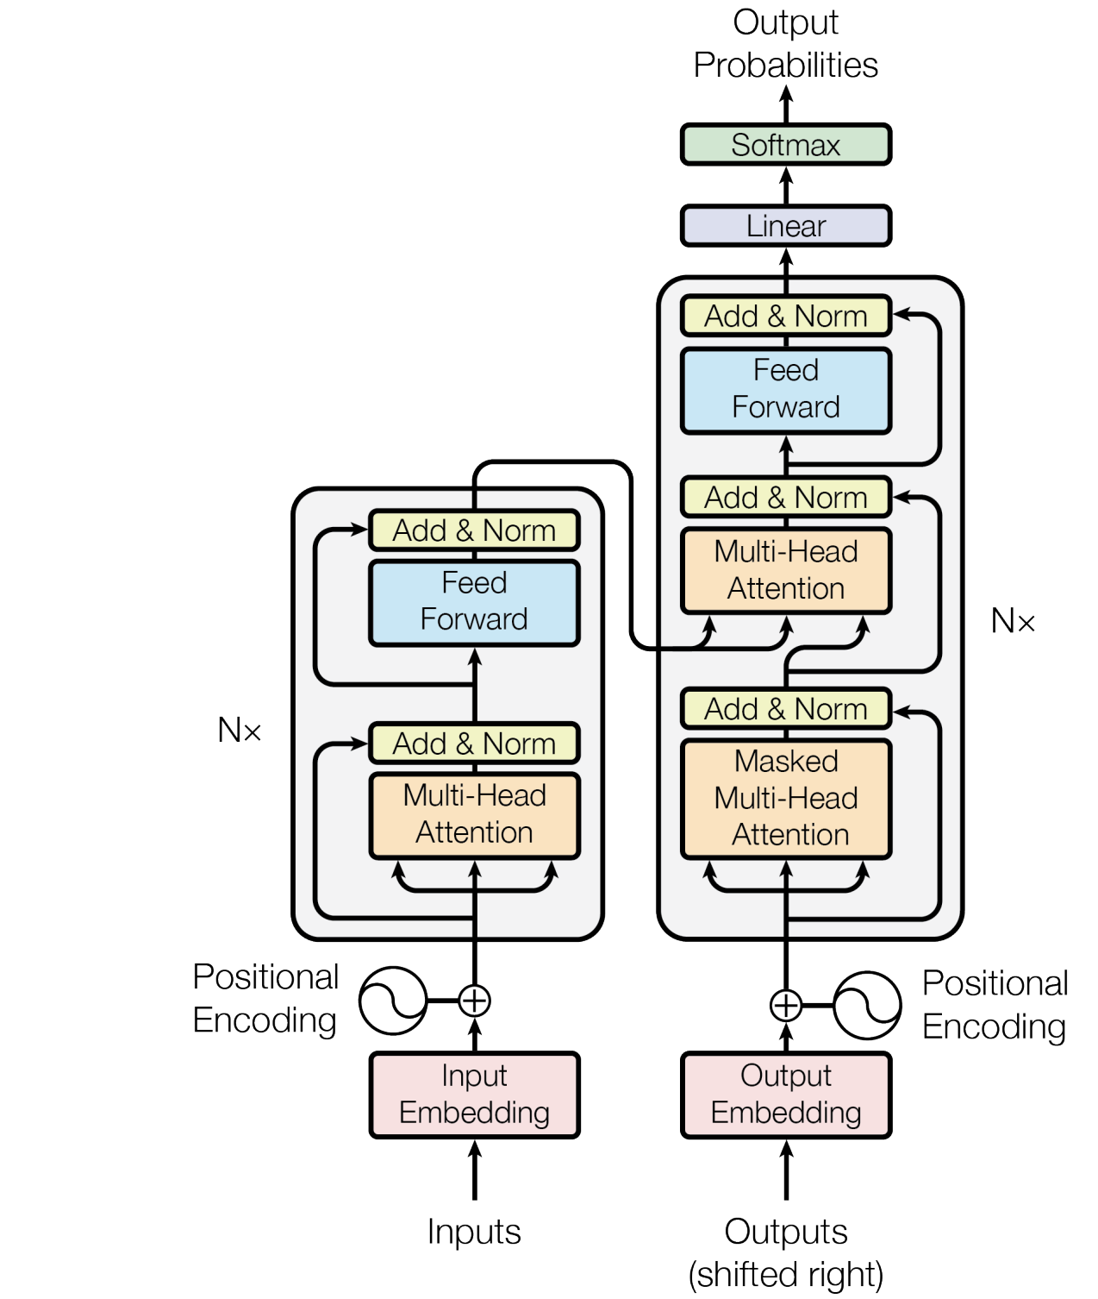
Below are the individual components/parts of each block of the transformer.
- Input Embeddings
The inputs are represented as tokens. Tokenization helps us to represent a given word/sentence into vector/tensor representation. We can use any pre-trained tokenizer to start with like sub-word/wordpiece/BPE tokenization.
- Positional Encodings
We need to define the contextual and neighboring words in a sentence/sequence. Transformer add some information about the relative or absolute position of the
tokens in the sequence. It adds the positional encodings to the input embeddings. It has the same size as the dmodel. It can be learnable or fixed encoding.
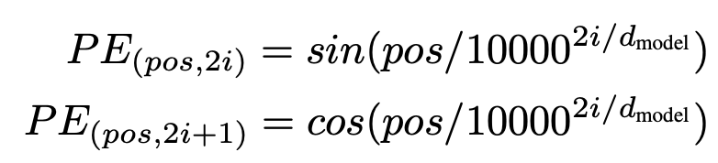
We chose the sinusoidal version because it may allow the model to extrapolate to sequence lengths longer than the ones encountered during training.

- Encoder Stack
The encoder stack defined as per the paper has 6 identical layers, each containing a multi-head self-attention, and a position-wise fully connected feed forward network. Including with a residual/skip connection followed by layer normalization.
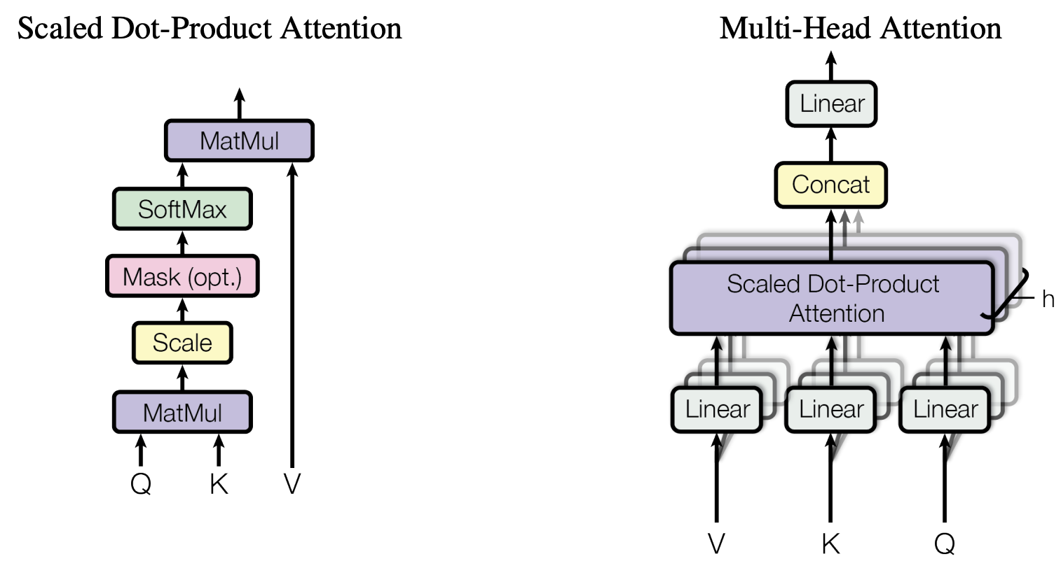
As shown in the diagram, we use a scaled dot-product attention block; it has three learnable matrices: Q(query), K(key), and V(value). The block applies matrix multiplication of Q@K, and we apply scaling to it by the square root of dk. Apply the softmax and multiply with V.
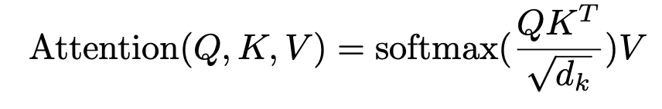

Dot-product attention is much faster and more space-efficient in practice, since it can be implemented using highly optimized matrix multiplication code.

The multi-head attention block linearly projects the queries, keys, and values h times with different learnable parameters. On each of the projects we can apply the attention block in parallel, later all the output of attention layers are concatenated and projected onto a linear layer.

  - Multi-Head Attention
    - Attention Layer (Self-Attention)
      - Scaled dot attention
      - Q,K,V
      - Q@K - mat multi
      - Scale
      - Mask (optional)
      - Softmax → x
      - x @ V - mat multi
    - Multiple scaled dot attention layers
    - Concat all attention layers
    - Linear projection

  - Add/Normalization
  - Skip Connection
The residual connection is added (handle gradient vanishing) on the values of multi-head attention outputs, and applied a normalization (exploding gradient).
  - Point-wise Feed Forward Network
On top of the attention layer in encoder and decoder, each module has a sub-layer of fully connected feed forward neural network consisting of two linear layers with ReLu activation.

  - Add/Normalization
The residual connection is added onto the result of feed forward network and applied a layer normalization.

- Decoder
  - Input Embeddings
  - Positional Encodings
  - Masked Multi-Head Attention (self-attention)
  - Add/Normalization
  - Skip Connection
  - Cross Attention
  - Add/Normalization
  - Skip Connection
  - FFN
  - Add/Normalization
  - Skip Connection
  - Projection Layer
    - Linear
  - Softmax

The decoder module is an auto-regressive network, it has very similar architecture to the encoder module except it has the masked multi-head attention and a cross-attention block.
The masked attention is helpful for auto-regression, it prevents the self-attention to attend the future positions while generating the next token. So the current token only depends upon only the previous context, whereas in encoder, the context is taken from all the words(tokens). We can set masking by setting the future positions to a very low value -inf (negative).

The cross-attention enables the transformer to attend each position of the input sequence to generate the output sequence. It uses Key(K), and Value(V) values from the encoder and uses its input sequence for the Query(Q).

Applications of Attention in our Model
The Transformer uses multi-head attention in three different ways:
• "encoder-decoder attention" layers, the queries come from the previous decoder layer, and the memory keys and values come from the output of the encoder. This allows every position in the decoder to attend over all positions in the input sequence.

• The encoder contains self-attention layers. In a self-attention layer all of the keys, values and queries come from the same place, in this case, the output of the previous layer in the encoder. Each position in the encoder can attend to all positions in the previous layer of the encoder.

• Self-attention layers in the decoder allow each position in the decoder to attend to all positions in the decoder up to and including that position. We need to prevent leftward information flow in the decoder to preserve the auto-regressive property. We implement this inside of scaled dot-product attention by masking out (setting to −∞) all values in the input of the softmax which correspond to illegal connections.

○ Compare and contrast the GPT and BERT architectures. In what scenarios might you prefer one over the other?

BERT
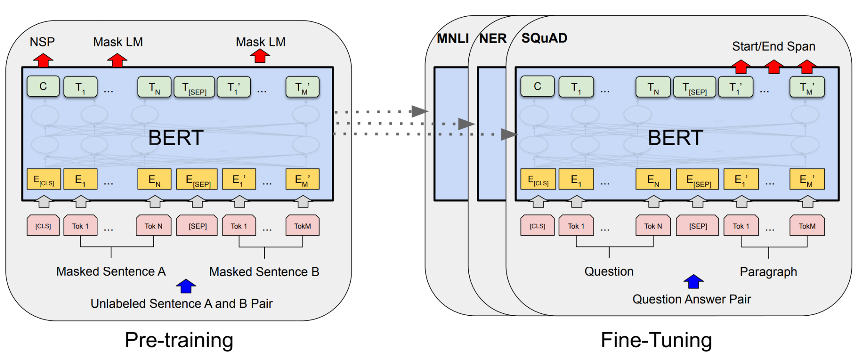

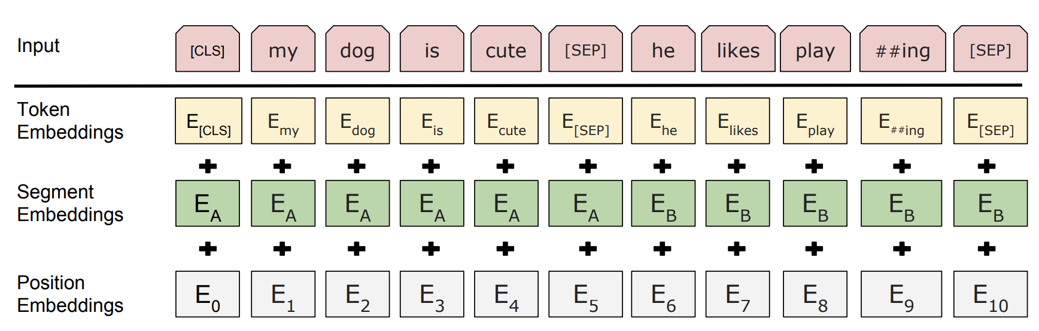

BERT Architecture-
Encoder only model
Language understanding model - understands the meaning of words in context (Masked LM)
User - Q&A, Text Analysis, NER, NSP

Bert is an encoder only model, as discussed in the transformer architecture. BERT uses only the encoder module with self-attention layer. We can add a task specific head on top of the encoder block to train the base model in a supervised or unsupervised way. BERT is usually trained for token classification tasks like entity recognition, masked language model like predicting missing token in a sentence or next sentence prediction tasks.

As shown in the above diagram, we can train the bert base model in an unsupervised way and later fine-tune to a task specific model.

GPT
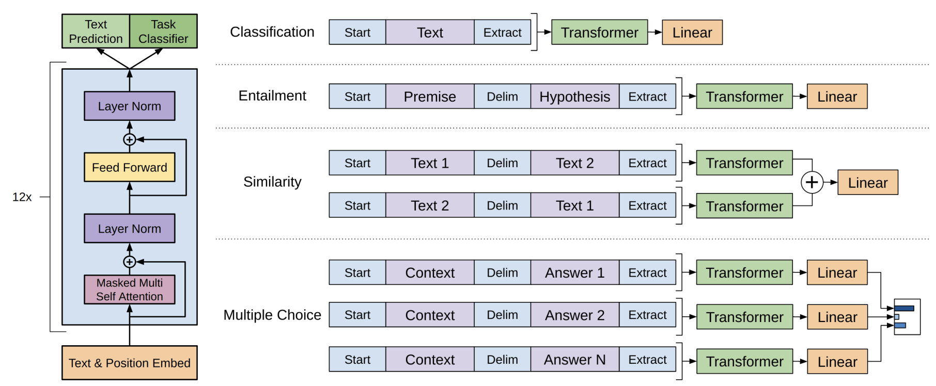
GPT is an auto-regressive model which contains only a decoder block with a casual masked self-attention block. It does not contain the cross-attention unlike the transformer decoder. We can train the base GPT model in an unsupervised way for tasks like NTP next token prediction in a sentence. The base model can be fine tuned to generate prompt/task specific content.

2. Training:

○ Describe the challenges and potential solutions of training very large models on distributed systems.

Large models are often trained on distributed systems because of the hardware limitation. Below are the few challenges faced for training such models on these systems-

As the amount of data grows exponentially, the model size is also growing which makes it impractical to train the models on a single node. We use distributed systems to train the large models, and as the model size increases, we need to have really large scale datasets. It gives rise to problems of computation, storage, and transmission in low-latency.

We follow three main strategies to train such models -

- Massive Data Scale
Because of the data size storing, transformation becomes challenging. Data storage and streaming can be a bottleneck in the model training pipeline. When the latency is high, we face communication overhead challenges. This problem can be solved by partitioning and distributing onto different workers while synchronization is the key point to consider.

- Large Model Size
As with the datasize, model size is algo growing, as today’s large language models have billions of parameters. Training such models is a challenging task as it does not fit onto a single node, so we use distributed/multi-node setup to load a single model in the memory and training. This often requires parameter sharing across the nodes, passing over the parameters from one system to another could be slow. We can use Distributed Shared Memory (DSM) to act as a Parameter server, allowing the model parameters to be shared across workers globally.

- Scalable Algorithms
The complete model training pipeline contains different modules, some traditional methods like Scikit-Learn and others might not have scalable algorithm implementations which support distributed processing.

○ How would you address the issue of vanishing and exploding gradients in deep neural networks, especially in the context of transformers?

Transformer implements below module/techniques to solve vanishing and exploding gradient problem.
- Self-attention: as traditional RNN/LSTM suffer from vanishing gradients due to the long sequence dependencies. Self-attention allows us to learn all positions simultaneously.
- Scaled dot-product Attention: the scaling factor in the attention module helps to control values from growing too large, the scaling factor provides a normalization such that values do not explode.
- Positional Encodings: we add positional encoding along with input embeddings, it helps the transformer to attend long context without sequential overhead, and helps in vanishing gradient problem of RNN/LSTM.
- Layer normalization
- Skip/Residual connection: both skip connection and layer normalization helps in vanishing/exploding gradient problem. Skip connection allows gradients to flow through the network and layer normalization stabilizes the activation.
- Parameter initialization: He-init or Xavier/Glorot initialization methods help with vanishing or exploding gradients.

Other general techniques for
Vanishing Gradient
- Weight initialization methods
  - Xavier/Glorot
  - He init
- Batch Normalization
- Gradient clipping
- Residual / skip connection

Exploding Gradient
- Gradient clipping
- Weight regularization
- Smaller/dynamic learning rate
- Normalization methods
  - Layer norm
- Optimizer selection
  - Adam
  - AdamW
  - LAMB
- Weight initialization
  - Keep normalized initial value
  - Avoid large value initialization

3. Optimization & Regularization:

○ Explain the mechanics of the Adam optimizer and why it's often preferred for training transformer models.

Adam (Adaptive Moment Estimation)
- computationally efficient
- less memory requirements
- invariant to diagonal rescaling of the gradients - exponential moving average
- well suited for problems that are large in terms of data and/or parameters.
- Adaptive learning rate
- Combination of momentum and RMSProp
- Handles sparse gradient

RMSProp keeps a moving average of gradients which helps in adaptive learning rate, Momentum methods helps in accelerating the gradient flow with small changes and noisy environment. Adam combines both algorithms RMSProp and momentum method.
Adam maintains two moving averages for each parameter: the first moment (mean) and the second moment (uncentered variance).

In context to Transformer, it adjusts the learning rate per parameter, and helps in avoiding large updates that could lead to exploding gradients.

As per paper reference:-
We used the Adam optimizer with β1 = 0.9, β2 = 0.98 and ϵ = 10−9 . We varied the learning rate over the course of training, according to the formula:
This corresponds to increasing the learning rate linearly for the first warmup_steps training steps, and decreasing it thereafter proportionally to the inverse square root of the step number. We used warmup_steps = 4000.

○ Discuss methods for regularizing large models to avoid overfitting. How do techniques like dropout or layer normalization play a role?

Dropout is applied to the outputs of the self-attention and feedforward layers in transformers. It helps prevent the model from relying too much on specific neurons and helps in generalization.

Layer normalization is applied to control the large values and smooth flow of gradient in the self-attention and feedforward layers in transformers.

Adversarial training can be applied to the transformer model by generating adversarial examples during training. It helps the model become more resistant to small perturbations in the input like typos, misspelling, or masked words.

Data Augmentation: we pre-process the data and create small perturbations like spelling-mistake, masked words, adding small noise. It helps to avoid memoization and better generalization.

Weight Decay (L2 Regularization): it is a common technique in machine learning to prevent overfitting. We can add a penalty term in the loss function.

Back-translation: for seq2seq models like language translation, to generalize better we can use back-translation such that it does not overfit.

4. Data Processing:

○ What are the challenges and strategies involved in preprocessing massive datasets for language model training?

Laget dataset size
Large datasets are computationally expensive to process, as discussed above we can implement a distributed parallel processing across multiple workers. The large datasets are alo memory intensive, so we can do streaming or batch-wise processing.

Vocabulary (OOV): to handle any new word or out-of-vocabulary, we need an efficient tokenizer to handle this like BPE, or sentencepiece.

Tokenization: it is a memory intensive task, handling large data requires a parallel implementation of the tokenizer, we can use some data-parallel tokenizers like sentencepiece, or hugging face tokenizer.

Imbalanced data: imbalance data can result in bias in the model, we do data exploration to find the distribution of classes, or biases in LLMs in terms of demography, gender, race, etc.

Data inconsistency
We do data preprocessing or cleaning before going to model training. There might be some inconsistencies at the data collection stage. We apply below techniques to data preparation-

- Normalization: generally a language has a really large vocabulary so remove Case sensitivity to limit the vocab_size. We remove the trailing/leading, or multiple whitespaces, and do some typo corrections.

- Special character: Remove/delete special characters that might be from some other language or a key character which might not be in the language such we tag it as (OOV) out of vocabulary.

- Stop word removal: we can remove the stop words where possible like “the”, “a”, “an” depending upon the task like text classification.

- Data Privacy: user privacy is very critical and a regulatory requirement, we can detect PIIs( Personally Identifiable Information) like PAN Card, SSN Number.

○ How would you handle multilingual or code-switched data in your training pipeline?

To support multilingual or code-switch we can have some common techniques for the both, and also specific techniques for each. Multilingual is a set of problems where the model has capability to handle multiple languages like English, German. Code-switching means the user/speaker uses multiple languages in the same conversation. It can be at word level or sentence level.

Multi-lingual:
- Dataset language tagging: at the time of dataset preparation, we should tag language specific text accordingly to identify/distinguish between supported languages.
- Language specific embeddings: can create separate embeddings/tokens for each language independently or another approach is to keep a global tokenizer to include all the word/sub-words.
- Language identification: we can have an additional module for language identification or create language specific embedding/tokens.

Code Switching:
- SwitchMLM: we can use a pre-trained model and fine-tune a masked language model task, where we curate the masking at language switch/boundaries. Curating such a dataset is a challenging task.
- Mixed language training: models such as mBERT and can make architectural changes in the model such as adding auxiliary loss, regularized(drop-out) skip connection.

Data Preparation
For data preparation we need a tokenizer to support multiple languages. We can use sub-word level embeddings like sentencepiece/BPE. This creates the joint semantic space of the words/subwords occurring in both the languages.

5. Evaluation & Benchmarks:

○ What are some key metrics for evaluating the performance of a language model? Discuss both quantitative and qualitative evaluations.
Evaluation methods

Quantitative
- Perplexity: measures the quality of text generation. Lower value defines good quality.
- ROUGE:
- BLEU: for the translation tasks, it defines the coherence and quality of generated text. It can define multiple scores as per the n-gram like BLUE-1, BLUE-2, .. BLUE-n. Higher BLUE scores define better text/output.
- F1 Score: indicates the overall quality which includes precision, and recall. It covers both false positive and false negative scenarios. For cases like classification, sentiment analysis, NER, it is a helpful metric. Higher F1 score is high performance.

Qualitative
- Human evaluation: it is best to include man in the loop to define the quality, coherence, and understability of the language model. We can include SME(subject matter expert) and crowdsourcing.
- User Feedback: we can collect feedback directly from the end user.

○ Describe the methodology behind designing a benchmark for language models. What are some existing benchmarks, and what might their limitations be?
Benchmarking involves creating a standard set of tasks, datasets, and evaluation metrics. It includes a diverse, real-world set of data and a wide variety of evaluation metrics that defines the near human performance of the model. The main methodology behind design the benchmark:
Goal specific: defining a clear goal of the benchmark, whether it is a general language understanding, task specific, mulit-lingual, etc.
Task centered dataset: depending on the model definition, as a single/multi-task, we should create the dataset accordingly to cover various aspects of the language.
Evaluation Metric:defining the appropriate evaluation metric is critical for ranking different models and ranking them in a systematic way.

Available popular benchmarks for the language models are:
GLUE: it has common tasks like sentiment analysis, text classification, semantic similarity, question answers, cross-lingual, etc. It has been reported to cover small context and less generalization challenges.
SuperGLUE: is an extension of GLUE covering the challenges of GLUE like reasoning, question answering. But still it has shown to have a limited capability.
SQuAD: (Stanford Question Answer Dataset) is a popular question answering dataset, it is a good dataset for contextual answers given a paragraph. It may not cover general real-world scenarios.
WikiText: it has a large collection of articles from Wikipedia. It covers a wide range of topics, and a good set for generalization capabilities.

6. Model Efficiency:

○ How would you approach compressing a trained language model without sacrificing too much performance?
Language models are really deep and large, and have big resource requirements. However, we have some methods to optimize the resource requirement at a menial cost of performance.

Quantization: the default datatype for the variables/parameters in the model is of higher order like (float32). Lower factor quantization has performance impact. We need to be careful regarding the data type to set for quantization.

Knowledge Distillation
- Teacher student model: is a technique to transfer knowledge/learning from a larger, complex model(teacher) to a smaller, simple model (student). This is a good approach to focus on the performance, as the rich knowledge of the teacher model is transferred to a smaller student model.
Low Rank Factorization (LoRA): it is a common framework now to train large language models. It adds new learnable parameters in terms of two matrices A, & B with a rank as hyperparameter. It significantly reduces the number of trainable parameters.
Model Pruning: it is an empirical technique to remove the neurons from the model at different stages like a complete layer, specific neurons in a layer. Sometimes, aggressive pruning might reduce the model size but can worsen the performance.

Other techniques can be used in combination of the methods like Knowledge distillation + Model Pruning.

○ Discuss the benefits and trade-offs of techniques like knowledge distillation, pruning, and quantization.

1. Knowledge Distillation:
Model Compression: Knowledge distillation allows the creation of smaller, more lightweight models (student models) that mimic the behavior of larger models (teacher models).
Transfer Learning: It allows knowledge transfer from a pre-trained, larger model to a smaller model, leveraging the pre-existing knowledge encoded in the teacher model.
Generalization: Distillation can improve the generalization of the student model, especially when the teacher model has seen a diverse set of examples.

Trade-offs:
Loss of Fine Details: The distilled model may lose finer features/details present in the teacher model, as it focuses on capturing coarse features.
Sensitivity to Teacher Model Quality: The performance of knowledge distillation heavily depends on the quality and diversity of the teacher model. If the teacher model is not well-trained or biased, it may transfer those shortcomings to the student model.

2. Pruning:
Model Size Reduction: Pruning removes unnecessary connections or parameters, leading to a more compact model with reduced storage requirements.
Computational Efficiency: Sparse models resulting from pruning require fewer computations during inference, leading to faster execution times.
Regularization Effect: Pruning can act as a form of regularization, preventing overfitting by removing redundant parameters.

Trade-offs:
Fine-Tuning Requirement: Pruned models often require fine-tuning to recover or improve performance, which may have additional computational costs.
Sensitivity to Pruning Thresholds: The choice of pruning thresholds can impact model performance, and finding the right balance between compression and performance is non-trivial.

3. Quantization:
Reduced Memory Footprint: Quantization reduces the precision of weights and activations, leading to a reduction in the model's memory requirements.
Faster Inference: Lower precision computations result in faster inference times, making quantized models suitable for deployment in resource-constrained environments.
Energy Efficiency: Quantized models can be more energy-efficient, making them suitable for deployment on edge devices.

Trade-offs:
Quantization Error: Reduced precision can introduce quantization errors, impacting the model's accuracy. Balancing precision and model size is a critical consideration.
Fine-Tuning Requirement: Quantized models may require fine-tuning to recover or improve performance, especially when using aggressive quantization techniques.

7. Ethics & Biases:

○ How do large language models inherit biases from their training data? Provide specific examples.
Language models can inherit bias from their training data due to bias present in the text corpora. It can be societal, cultural, or historic. For example,
- a profession is particularly biased with a gender
- Ethnicity
- A particular party/organization is portrayed better than others
- Sentiment bias
- Cultural bias

○ What strategies can be employed to identify and mitigate these biases during model training or post-training?
We can include few techniques/methodology before/during model training like
- Diverse training dataset
- Bias detection/reduction
- Ethical guidelines

8. Transfer Learning & Fine-tuning:

○ Explain the concept of transfer learning and how it's particularly relevant in the context of large language models.

Transfer learning is a technique in machine learning to use the knowledge of one task and use it to improve similar related tasks. It helps to reduce training time, improve model performance, and reduce training data requirement, and feature extraction. In context to the language model, we use the BERT/GPT based model to get the feature embeddings of the token sequence.
Using the pre-trained model helps with general language understanding, and/or adaptation to the specific task. For example we can build a NER/Token classification model with BERT as the base model, or a language translation model using a transformer based like mBart. Similarly can use GPT for domain specific text generation.

○ How would you approach fine-tuning a pre-trained language model for a specific downstream task? Discuss potential pitfalls and best practices.

Fine-tuning helps us to improve the model performance for the specific downstream task. The model parameters get updated/adapted to the new domain/task. It involves tweaking model architecture, curated dataset training, or hyperparameter tuning. We can keep a few/all layers of the pre-trained model freezed and partially update/train the model to tune as per our need.
- Data Preparation: we can follow similar steps for data preparation as discussed above like data cleaning, normalization, bias mitigation.
- Model training: depending on the performance, we can gradually unfreeze the layers of the pre-trained model, this will update the model parameters through backpropagation.
- Hyperparameter tuning: changing/modifying the hyperparameters like learning rate, batch-size, epochs can help in better performance of the model.

9. Tokenization:

○ Compare and contrast character-level, word-level, and subword-level tokenization methods. What are their advantages and limitations?

Tokenization is the process of breaking down sentences/words into a smaller unit called tokens, which are the building blocks/inputs to the language model.
Character level tokenizer: each word is broken down to an individual character. For example the word “hello” is represented as [“h”,”e”,”l”,”l”,”o”].
- It can be treated as language independent
- Handles Out-of-Vocabulary
- Fails to capture the semantic meaning
- Has a long sequences

Word level tokenizer: the token is an individual word. For example “hello world” is represented as [“hello”, “world”].
- Captures semantic meaning
- Interpretable tokens
- Language dependent
- Fails to handle out-of-vocabulary words

Subword-level tokenizer: a word can be used as a token or might be broken down into smaller segments (subword). For example “learning” can be represented as [“learn”, “##ing”]
- Handles out-of-vocabulary words
- Vocabulary could be large
- Subwords may not be interpretable.

○ How do models like BPE or SentencePiece handle out-of-vocabulary words, and what benefits do they bring in the context of large-scale language models?
BPE or SentencePiece both are subword-level tokenizers.
BPE breaks down each word to the smallest part (character-level) and then it builds the vocabulary by iteratively replacing the most frequent pair of bytes/sub-words in a sequence such as n-gram character representation. However, it is a lossy tokenization, the raw input text is difficult to reconstruct.
SentencePiece treats whitespaces also the part of sequence and replaces them with a special token “_” and then iteratively builds up the subword level tokenization. It is a lossless tokenization and can decode the token into raw input text.
These methods provides benefits to the language models like
- Handle out-of-vocabulary words/tokens
- Dynamic vocabulary
- Generalization to unseen data.

10. Model Interpretability:

○ Why is it challenging to interpret decisions made by deep learning models, particularly transformers?
Neural networks/deep learning models have complex and large model architecture. It has a very large number of parameters and can be easily in billions of parameters. Interpreting such a model is a complex task. For models like transformers has
- Large number parameters
- multiple hidden layers
- Non-linearity
- Attention mechanism
- Higher dimensionality
- Input embedding
Makes it difficult to explain/interpret at sub-model/layer level.

○ Discuss methods or tools you might employ to improve the transparency or explainability of large language models.
We can use some methodology like
Attention Visualization: tools like BertViz helps to visualize the attention layer to understand the token and context relationship
Ablation Study: it is a process of understanding sub-module level features/outputs. We can remove top layers and see the model response in inference.
Probing: we can add some classifier layers onto the intermediate layers. The objective is to understand the impact of each such intermediate layer.

Other techniques like
- Rule based explanation
- Attention Heatmaps

11. Data Acquisition:

○ How would you prioritize and select data sources for training a versatile language model? Discuss considerations like diversity, representativeness, and potential biases.

Data acquisition is the most critical step in the model building pipeline. We need to be very cognizant about the following -
Diverse Content: we should include data from various domains, and backgrounds like academic journals, news articles, social media etc in multiple languages for global uses.
Demographic Coverage: data should have all age groups, gender, cultural background etc.
Quality Sources: data sources should be reliable and updated, e.g. news agencies.
Bias Mitigation: we should analyze the data for Gender, Race, Cultural Biases etc and replace the data with the content which represents the minority.
Ethical Compliance: we should respect privacy of the user and content, only consented data should be used for the development purposes.
Task Specific Data: data should align with the particular task. For example- for a customer service bot we need data which emphasize dialogues and customer interactions.
Continuous Updates: data should be regularly updated based on feedback, and sources.

○ Describe the potential pitfalls of web-scraping as a primary data source for language model training.
WebScraping is a method to extract/download data from websites, it is an internal part of machine learning developments for collecting more data. However, it has many pitfalls like in terms of data quality, purpose, and regulatory compliance, and we should be aware of these-

Content Duplicacy: there are many websites hosting blogs, content, or tutorial references so people post the same content on different portals. For example- sharing same/similar content on medium blogs, personal websites, or LinkedIn. Also, different users create content on the same topic which becomes a tedious task to identify the duplicacy of content. We need to do a pre-processing step manual/automated to check the duplicate content.

Quality and Reliability: the quality of the text is always a big problem in data scraping. Users have their freedom of content creation, and it is not regulated. So we should only keep high quality content websites like research journals, new agencies. There are also instances that circulate fake news or incomplete/wrong information on the internet, it requires continuous monitoring of the data sources, and we should block/blacklist if any such incident is found.

Diversity and Biasness: As discussed above there are many articles/data which is duplicated so diversity is also a concern and difficult work. Also, there are many biases on the internet content, people from a particular group/ethnicity can have human biases which is reflected in the content as well.

Legal and Ethical Issues: we should always check for the use of the dataset collected, if the user has given the consent to train the model for commercial or research purpose. We should avoid data scraping for which it is not licensed or consented. It might cause regulatory or legal issues to the business.

Inappropriate Language: Nowadays, a lot of content on reviews, micro-blogging, people use inappropriate language like new terms, abbreviations, incorrect grammar or slang words. Without supervision, models might learn these terms.

12. Hardware & Infrastructure:

○ When scaling up a model's size, what hardware bottlenecks might you anticipate? How can these be mitigated?
Scaling up model size helps with better generalization and improves performance. However training these models poses challenges for resource/hardware requirements.

Memory Bandwidth: the number of model parameters become very large as the size scales up, also the size of the layer might increase. Matrix operations might require large memory. We can choose to
- optimize the model operations like quantization or low rank factorization
- use the GPUs with higher memory
- use distributed nodes with multiple GPUs.
- use mixed-precision training and gradient checkpointing.

GPU Compute Capacity: Larger models require more computational power, we can use GPUs with higher compute capabilities, distribute training across multiple GPUs, or use specialized hardware like TPUs.

Storage Bandwidth: Storing and retrieving model checkpoints and data on the storage can be a limitation. We can use high-speed storage solutions like SSDs or NVMe drives. We can optimize data loading with distributed data pipelines and streaming.

CPU Bottlenecks: cpu operations like data streaming, tokenization can be an overhead for small compute resources. We can optimize data preprocessing pipelines, offload tasks to specialized libraries, and consider high-performance CPUs.

○ Discuss the trade-offs between training on TPUs, GPUs, and CPUs. When might you prefer one over the others?

CPUs (Central Processing Units), Training on TPUs (Tensor Processing Units), and GPUs (Graphics Processing Units) each offer distinct advantages and trade-offs depending on the nature of the task, the scale of computation, and the specific requirements of the project.

CPU (Central Processing Units):
General-purpose processors with widespread support and compatibility across all types of tasks and software. It typically costs less than GPUs or TPUs, especially for smaller-scale deployments.

CPUs have slower performance for deep learning tasks compared to GPUs or TPUs. and have limited parallelism and throughput.

We prefer CPUs for small-scale deep learning tasks, prototyping, or tasks where deep learning is only one component of a larger pipeline.

TPUs (Tensor Processing Units):
TPUs typically offer higher throughput and better performance for deep learning workloads than GPUs or CPUs. It is well-suited for training large-scale models, especially when training times need to be minimized.

Prefer TPUs for large-scale deep learning tasks, such as training complex neural networks on massive datasets, where performance and throughput are critical.

TPUs might not be as widely available as GPUs or CPUs.

GPU (Graphics Processing Units):
General-purpose parallel processors with wide availability and support across various deep learning frameworks (e.g., TensorFlow, PyTorch, etc.). It offers significant speedups over CPUs for many deep-learning tasks due to their highly parallel architecture.

Memory constraints on GPUs might limit the size of models or batch sizes that can be trained.
We prefer GPUs for medium to large-scale deep learning tasks where speed and parallelism are important.

13. Scalability & Parallelism:

○ How do techniques like model parallelism and data parallelism differ, and when might you use each?

Data parallelism:
In this technique we divide the data into batches and each batch is allocated to a different device, in this case each device contains the full copy of the model and each model calculates trainingloss to its assigned batch independently. These losses are then averaged and used to update the model parameters on all devices. Using data parallelism we can reduce the model training time as multiple device process data simultaneously. Data parallelism is useful when a full model can be loaded on the single device memory, if the model is too large to fit on single device memory data parallelism can not be used.
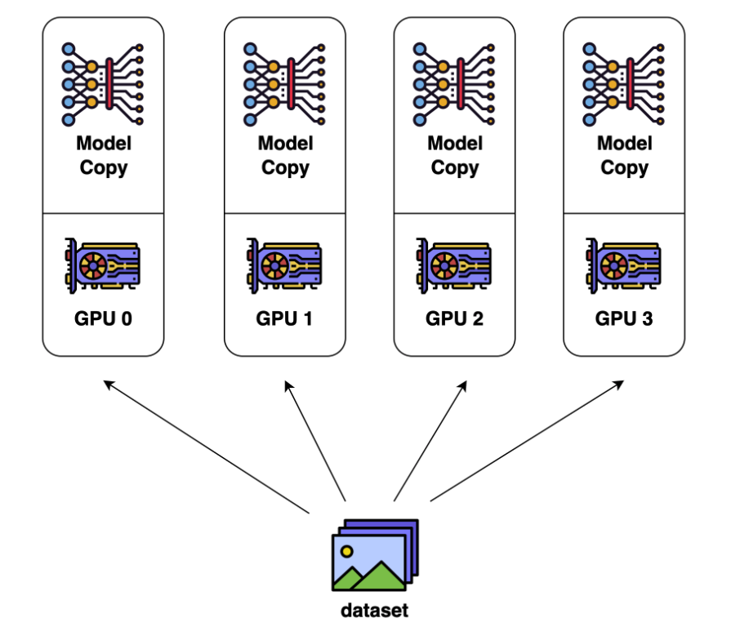
Image Ref : https://colossalai.org/docs/concepts/paradigms_of_parallelism/

Model parallelism:
In this technique we split the model itself into smaller parts and each part is loaded on a different device. Each device has some portion of the model and performs calculations on that portion. The synchronization is required between the devices to pass the intermediate results and update the complete model parameters. Using the Model parallelism we can train much larger models but the drawbacks are much more complex to implement because synchronization between all devices are needed and the model training time is increased due to the communication overhead.
Within model parallelism, we have Tensor parallelism and Pipeline parallelism.
Tensor parallelism:
Tensor parallel training splits a tensor into N chunks along a specific dimension, and each device only holds 1/N of the whole tensor while not affecting the correctness of the computation graph. This requires additional communication to make sure that the result is correct.
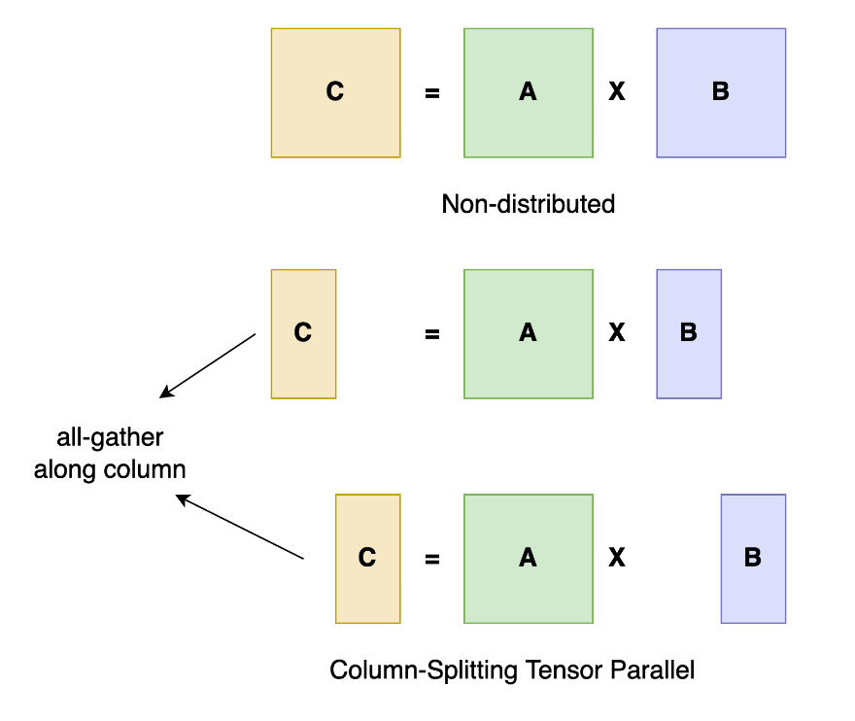
https://colossalai.org/docs/concepts/paradigms_of_parallelism/

Pipeline Parallelism:
The core idea of pipeline parallelism is that the model is split by layer into several chunks, each chunk is given to a device. During the forward pass, each device passes the intermediate activation to the next stage. During the backward pass, each device passes the gradient of the input tensor back to the previous pipeline stage.

This allows devices to compute simultaneously and increases the training throughput. One drawback of pipeline parallel training is that there will be some bubble time where some devices are engaged in computation, leading to a an idle state of computational resources.
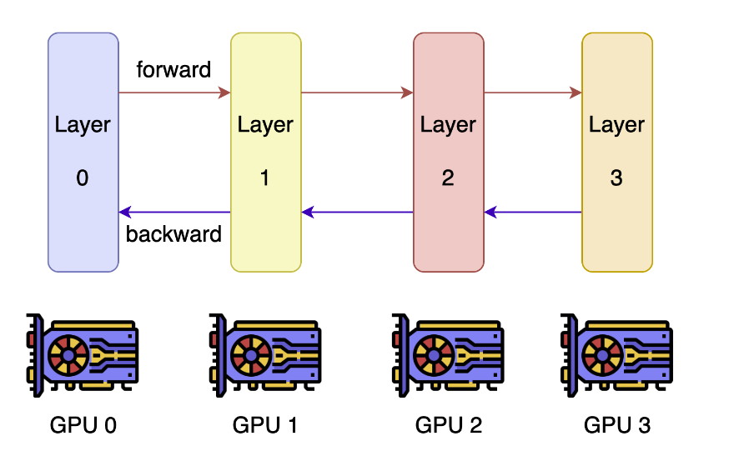
https://colossalai.org/docs/concepts/paradigms_of_parallelism/

The choices between data parallelism and model parallelism depends on the data size and model size, if we have model which can fit single device memory, and have multiple devices are available then data parallelism is best choice because using data parallelism we can train model faster, if model is too large to fit in single device then model parallelism is the best option.

○ Describe a scenario where distributed training would be advantageous, and outline the steps you would take to implement it.

Suppose we're working on training a large language model(LLM) using a dataset with billions of articles and a deep neural network architecture like GPT or MoE(Mixture of Experts). The goal is to achieve state-of-the-art performance on this dataset, but training such a model on a single machine with limited computational resources would be impractical due to the sheer size of the data and the computational complexity of the model.

We take following steps to implement distributed training:-
- Data Parallelism: divide the dataset
- Model Parallelism: split the model
- Choose a Distributed Training Framework: As an example, pytorch off the shelves APIs to implement Data and Model Parallelism. https://pytorch.org/docs/stable/pipeline.html

14. Model Serving & Deployment:

○ What are the challenges of deploying large models in a production environment, especially concerning latency and throughput?
Deploying large models in the production environment has many challenges in terms of latency, throughput, and scalability.
Hardware requirement: due to the size of model and compute requirement, it needs specialized hardware like GPUs/TPUs to run on. We can use dedicated TPUs/GPUs and also implement hardware acceleration methods.
Model inference latency: large models have latency to generate/predict the output, to serve multiple requests sequentially would add exponential latency if request load increases. We can have priority queues, inference batching, or model output caching.
Model Scalability: having a good deployment strategy would help to address the scalability problem when the number of inference requests increases on the system. We can follow cloud services with auto-scaling support.
Network latency: the model service should be closer or within the same network for the application to server faster. Keeping the model in a different network cluster or zone, would add additional latency.

○ Describe strategies for efficient model serving, considering factors like caching, batching, and hardware acceleration.
When serving models in the production we can follow these strategies to improve the efficiency, latency, and hardware utilization.
Model compression: large models require big compute resources, we can implement model compression techniques like quantization, distillation, LoRA can use libraries like deepspeed, gptq, or bitsandbytes that reduces the hardware requirements and also allows faster compute.

Attention Caching: in transformer-like architecture the time complexity increases quadratically for the attention layer with the token size. We can implement attention caching to save the compute time, it might increase the memory requirement. We can use with paged attention to optimally use memory and caching.

Inference Batching: large models like text generation(LLMs), auto-regressive generate tokens sequentially in a stream, it increase the latency for the new requests. We can implement batching and infer multiple requests like a batch of input to the model.

Hardware Acceleration: we can implement/use accelerated libraries which makes the inference faster, libraries like deepspeed, or megatron based model architecture.

16. Continuous Learning:

○ Discuss the concept and challenges of online learning for large language models. How can a model be updated with new information without a full retraining?
Online Learning allows us to keep the model updated constantly with the new information/data, and improving the performance. Instead of retraining the complete model on the large data, online learning allows the model to learn in smaller chunks in close to real-time. For example updating an LLM with latest news articles.

However, it has many challenges in the process-
Catastrophic forgetting: while learning on new data, models can overwrite/shift towards new data and forget previously learned knowledge. It may lead to the model degradation.
Data drift and bias: the regular flow of new data should be carefully curated to avoid biases, and any irrelevant information.
Computational cost: training a large model is expensive compared to the inference/serving, so we need to have appropriate hardware setup to train the model continuously even if in small batches.

On-line learning is a large topic and we can follow below strategies to implement for the language models.

○ How would you handle potential negative feedback loops when users interact with and influence a continuously learning model?
On-learning is a great technique to keep the model updated with the latest knowledge base.
We can implement few methodologies to address above challenges-
Selective Sampling: we need to curate the dataset even keeping a human in the loop to sample the quality dataset.
Continual learning: we can implement algorithms for continual learning like regularization-based methods.
Federated Learning: if possible we can make use of individual setups to train the model and aggregate the final result centrally.

17. User Interaction & Feedback:

○ What strategies might you employ to collect and incorporate user feedback to improve a hosted language model?
Active feedback
- In-app: having an option in the application to provide the feedback about the model prediction.
- Survey: can ask users to fill a survey form
- Review: keep a log/record of review and comments
- Social-media: monitoring social media feeds mentioning about the product.
A/B testing: before final roll-out, we can do internal testing, and can open to a limited number of users in the controlled environment to test and provide feedback.
Error logs: we should capture and save the logs continuously it help to analyze the service health, uptime, throughput and overall performance.

○ Describe a system where users can flag inappropriate or incorrect model outputs, and how this data can be used for model refinement.
User feedback: we should have an option/API to provide a feedback, for example having a like/dislike option
Review/comment: we can give an option to write the comment or review about the model behavior or performance.

18. Cost & Resource Management:

○ Large language models can be expensive to train and deploy. How would you plan and optimize resource allocation across data acquisition, training, and hosting?

LLMs are expensive to train due to the model size and amount of data requirement. We can employ the following strategies to orchestrate the training and deployment.

Data Acquisition:
- Identify and acquire high-quality training data relevant to the requirement and domain.
- Consider data augmentation techniques to increase the diversity and size of the training dataset without requiring additional data acquisition efforts.

Training:
- Select an appropriate deep learning framework and infrastructure for training the language model like pytorch, nvidia-dgx server(s), considering factors such as scalability, cost-effectiveness, and support for distributed training.
- Optimize hyperparameters, model architecture, and model algorithms to maximize training efficiency.
- Explore techniques such as distributed training, mixed precision training, and model parallelism to leverage parallel computing resources effectively.
- Use libraries like deepspeed, bitsandbyte.

Deployment:
- Consider options such as cloud-based infrastructure (e.g., AWS, Google Cloud, Azure), on-premises deployment, or serverless architectures based on the specific needs of the application.
- Implement caching, load balancing, and auto-scaling mechanisms to handle request demand and optimize resource usage dynamically.

Cost Management and Optimization:
- Implement cost monitoring and alerting mechanisms to detect anomalies, unexpected spikes, or inefficiencies in resource usage.
- Leverage cost optimization techniques such as reserved instances, spot instances, auto-scaling, and resource tagging to minimize costs without sacrificing performance or reliability.

○ Discuss strategies for model monitoring in production. What metrics would you prioritize to ensure model health and cost-effectiveness?
We can monitor the model performance using an evaluation metric like
- BLUE score
- Perplexity
- User feedback

For resource utilization to make it cost-effectiveness we should monitor
- Latency
- Throughput
- CPU/GPU utilization
- Memory utilization
- Model availability (crashed/uptime)

19. API Design & Integration:

○ When designing an API for third-party developers to access your language model, what considerations would you prioritize?
While sharing the model service with third-party we should be consider the following-
Ease of Use: can design the API using a widely acceptable framework like RESTful.
Keeping with clear documentation to define the request payload and response structure and can have a postman workspace to be shared.
Security: implementing authentication and authorization for safe and secure usages.
Reliability: ensuring rate-limit, and user quotas, and keeping the server uptime to be available for the users.

○ How would you design a system to handle potential spikes in user requests, ensuring consistent performance?
We can implement scaling options to serve the spikes in user requests-
- Horizontal scaling: using cloud services or containerization to dynamically add/remove servers as per the traffic.
- Vertical scaling: upgrading the server to more powerful server (CPU/GPU)
- Load balancing: implement a load balancer to distribute the user request across available servers.

20. Model Versioning & Iteration:

○ Discuss the challenges and strategies for managing multiple versions of a large language model, especially when user-specific customizations or domain adaptations are involved.
Model versioning is an important part of the ML development pipeline. We can consider the following challenges and strategies to follow-
Version control platform:
- Github: it is a popular and developer friendly tool to monitor the progress and track file changes.
- Model zoo: keeping a model zoo library with version-number can help to easily deploy new version or roll-back to a specific version.
Model Serving: should use platforms like tensorflow-serving, torch-script to manage loading & switching between different versions.

Librairies: MLflow is a popular framework to manage ML workflows that includes model versioning, tracking, and deployment.

○ How would you test and safely roll out updates or improvements to a production model without disrupting current users?

Testing strategies
Unit Testing: write basic test cases to ensure the functionality of the service.
Integration Testing: ensure the compatibility with existing applications/service for integration.
Automated Testing: implementing automated scripts to test different scenarios before rollout.
Beta testing: can softly rollout to selective users, and gather feedback

Roll-out strategies
Monitor metrics: keep track of the model performance metrics, and user feedback
Rollback plan: keep the strategy to rollback to a previous version if needed.

